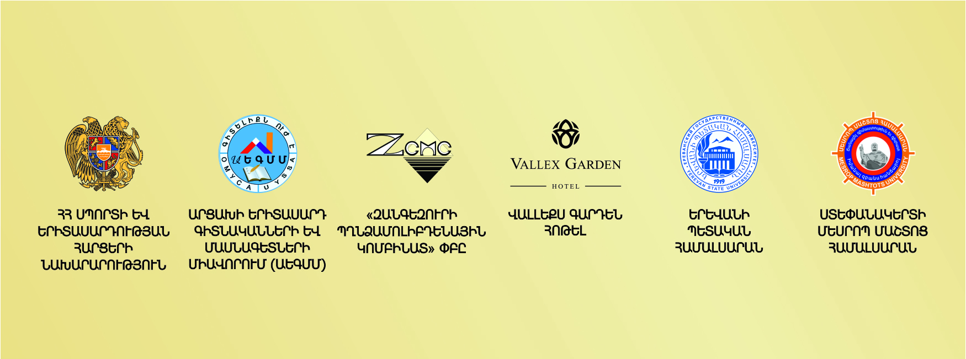

**Application Form for**

**IV International Youth Scientific Conference**

**«THE PAST, PRESENT AND FUTURE OF THE ARMENIAN STATEHOOD»**

(Stepanakert, 12-15 September 2019)

|  |  |
| --- | --- |
| **Name/Surname** |  |
| **Date of birth** |  |
| **Academic degree** |  |
| **Educational Institution (Department, Chair)** |  |
| **The Heading of the Report**  **(English and Russian)** |  |
| **Academic adviser’s name/surname and academic degree** |  |
| **Form of participation (full-time / correspondence)** |  |
| **Country (city/town)** |  |
| **Address of residence (with zip code)** |  |
| **Phone number(s)** |  |
| **E-mail Address** |  |
| **Facebook ID** |  |

Please send the fully filled application form with the article to the following email address [armstatehoodconf@gmail.com](mailto:armstatehoodconf@gmail.com) **by July 31, 2019**.

For additional information please contact Avetik Harutyunyan, Ph.D in law, Associate Professor, the chairman of the organizing committee at [avetiq.hh@aegmm.org](mailto:avetiq.hh@aegmm.org).