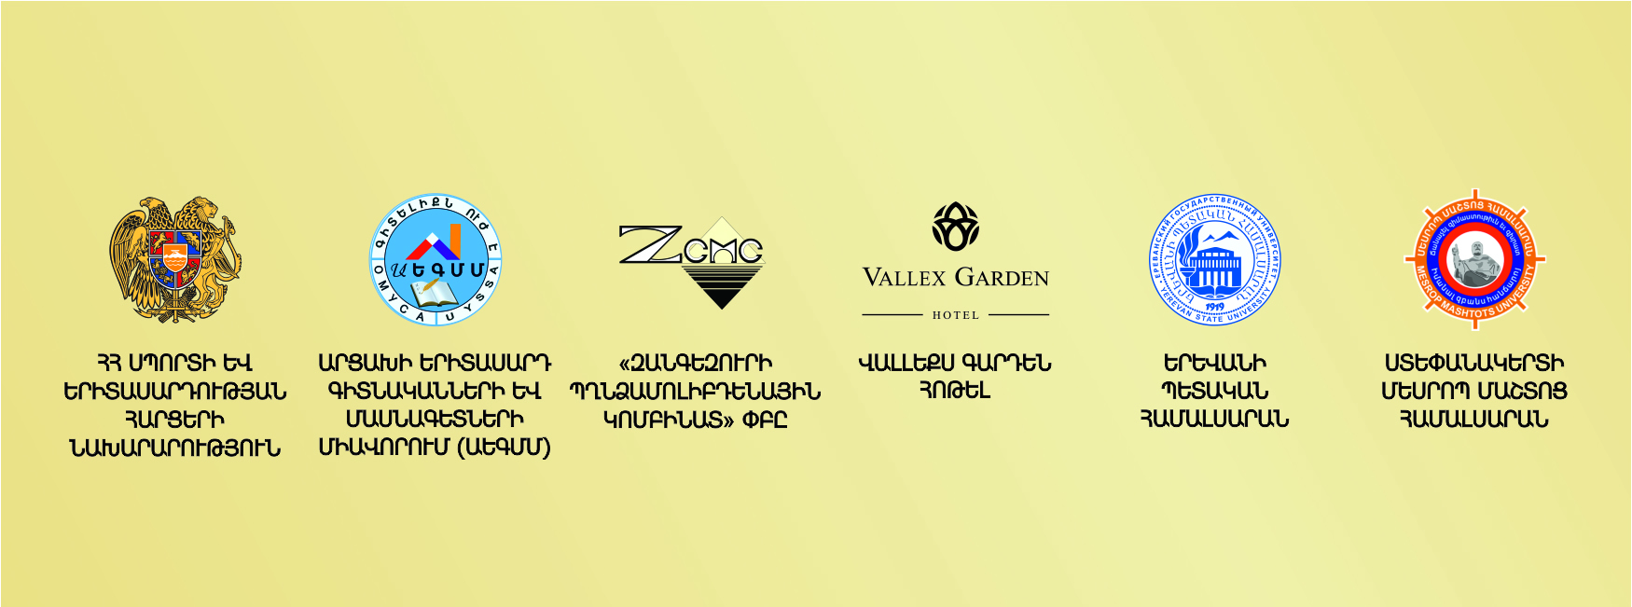

[**https://artsakhlib.am/en/2019/04/15/english-international-scientific-conference/**](https://artsakhlib.am/en/2019/04/15/english-international-scientific-conference/)

**I N F O R M A T I O N L E T T E R**

#### IV International Youth Scientific Conference «THE PAST, PRESENT AND FUTURE OF THE ARMENIAN STATEHOOD»

#### (Stepanakert, 12-15 September 2019)

**On September 12-15, 2019**, the «Union of Young Scientists and Specialists of Artsakh (UYSSA)» NGO together with Yerevan state University and Stepanakert Mesrop Mashtots University will organize the IV International Youth Conference **«The Past, Present and Future of the Armenian Statehood»** in Stepanakert, the capital of the Republic of Artsakh

The conference is open to post-graduate students/applicants, young scientists and specialists of universities and research centers of Artsakh, Armenia and foreign countries (the age of participants should not exceed 35 years, except for scientists invited by the Organization).

**Conference directions:**

* jurisprudence;
* political science;
* international relations;
* history;
* economy;
* sociology;
* pedagogy;
* psychology;
* philology and others.

**Topics to be discussed at the conference:**

1. Theoretical and practical issues of statehood.
2. Armenia – Artsakh – Diaspora relations and pan-Armenian problems.
3. Topical challenges of social and economic development of Armenia and the Republic of Artsakh.
4. Issues of self-determination, formation and international recognition of the Republic of Artsakh.
5. The origin of the Karabakh conflict and the process of its settlement.
6. Recognition of the Armenian Genocide and the legal responsibility of Turkey.
7. Socio-political development and problems of recognized and non-recognized Post-Soviet countries.
8. Issues of constitutionalism establishment in recognized and non-recognized States.
9. Perception and comprehension of the great Armenians’ heritage in our days.

The article should correspond to one of the above-mentioned topics.

The best works of the conference will be published in the ***«Scientific Artsakh»*** journal, included in the list of peer-reviewed scientific publications of the RA HAC.

To participate in the conference, you must fill out an [application form](http://artsakhlib.am/wp-content/uploads/2019/04/Application-Form-Stepanakert-city-12-15.09.2019-1.docx) and send it to the [armstatehoodconf@gmail.com](mailto:armstatehoodconf@gmail.com) by **July 31, 2019.** Along with the application, it is also mandatory to send:

* scientific article;
* review of an academic adviser or a recommendation letter (the scan) of the relevant Department (only for participants who do not have an academic degree).

**Conference languages:** Armenian, Russian, English.

**Conference sponsors:** Ministry of sports and youth Affairs of the Republic of Armenia, «Zangezur Copper-Molybdenum Combine» CJSC and «Vallex garden hotel» CJSC.

**Information partners of the Conference:** Artsakh Public Television, Armenian Information Center, “Our environment” online and “Artsakhpress” news agencies, “Azat Artsakh” Republican newspaper.

**Technical requirements for works:**

**Computer typing:** program MS Word 2003-2010.

**Page format:** B5 (176*250 mm), margins (left, right, top, bottom)` 20 mm.

**Volume:** 7-20 pages (summary inclusive).

**Text font:** Armenian-Arian AMU (font can be downloaded [here](http://arian.am/arnamu.zip)), Russian and English – Times New Roman.

**Language of articles:** Armenian, Russian, English.

On the top line of the first page (center alignment) in capital letters, bold, font size – 13 pt the title of the article is written. Over the line, in the center of the line, font size – 12 pt, capital letters, bold the name(s) of the author(s) is indicated. In the center of the line below, font size 12 pt, italicized the place of work, University or research center, faculty, scientific degree, title, city and country are indicated. On the line below in the center, font size 12pt the author’s email is provided.

Over a line, font size 12, bold, italic an abstract (ամփոփում, аннотация), in the 120-170 words amount including forth goals, objectives, research methods, and main conclusions of the author must be set. The abstract should be a separate text describing the main results of the study without reading the article.

Over a line the word **«Keywords»** must be written and 7-10 words must be specified.

Over a line, the main text of the work with the font size of 12 pt, line spacing of 1 pt must be submitted. The text should be aligned on both sides (Alignment: Justify). The paragraph should be started with an indentation of 1 cm, using the TAB:

Tables should be numbered and have titles.

Diagrams, schemes and drawings must be clear and printable.

Abstracts in two languages other than the language of writing are required and they represent the translation of the initial part of the article (from the title to the keywords inclusive) and are indicated after the main text.

References required are listed in the bottom of the page, on the rise, font size 10 pt with line spacing 1pt. The link text must be aligned on both sides (Alignment: Justify). Paragraphs begin with a space of 1 cm, using the TAB: The link indicates the name and the first letter of the author’s name of the source used (Bold), then the title of the work, volume, place of publishing, year and page.

An example of the article can be found [here](http://artsakhlib.am/wp-content/uploads/2019/04/%D0%90%D0%B2%D0%B5%D1%82%D0%B8%D0%BA-%D0%90%D1%80%D1%83%D1%82%D1%8E%D0%BD%D1%8F%D0%BD-%D0%9A%D0%BE%D0%BC%D0%BC%D0%B5%D0%BD%D1%82%D0%B0%D1%80%D0%B8%D0%B8-%D0%BA-%D0%9A%D0%BE%D0%BD%D1%81%D1%82%D0%B8%D1%82%D1%83%D1%86%D0%B8%D0%B8-%D0%A0%D0%B5%D1%81%D0%BF%D1%83%D0%B1%D0%BB%D0%B8%D0%BA%D0%B8-%D0%90%D1%80%D1%86%D0%B0%D1%85.docx).

Articles that do not meet these requirements will not be accepted for consideration.

Transfer Yerevan – Stepanakert – Yerevan will be organized FREE of charge. Expenses of foreign participants related to accommodation and meals are borne by the organizer of the Conference.

**Chairman of the Committee:**

**Harutyunyan Avetik H.** – Ph.D in Law, Associate Professor, founder and Chairman of the Union of Young Scientists and Specialists of Artsakh (UYSSA), lecturer of the Artsakh State University and  Mesrop Mashtots University.

Tel. (+374) 97277770, E-mail address: [avetiq.hh@aegmm.org](mailto:avetiq.hh@aegmm.org)

**Тhe history of the Conference:**

**On September 15-18, 2016,** the First International Youth Conference **"The 25th Anniversary of the Statehood of the Nagorno Karabakh Republic (Artsakh Republic): Achievements and Modern Challenges"** was held in Stepanakert, which was attended by 77 participants from 5 countries, including professors from Germany, Poland, the Russian Federation, Armenia and Artsakh.

Video material on the conference: <https://www.youtube.com/watch?v=3hofGaraBUw>

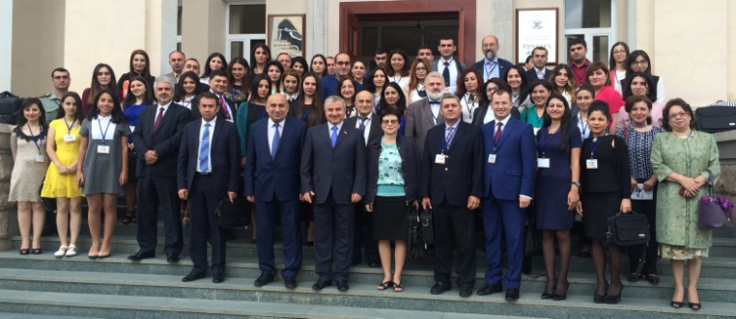

**On September 14-17, 2017,** Stepanakert hosted the Second International Youth Conference **"Problems and Prospects of International Recognition of the Republic of Artsakh",** which was attended by 63 participants from 7 countries, including professors from the USA, Germany, Poland, the Russian Federation, Ukraine, Armenia and Artsakh.

Video material on the conference: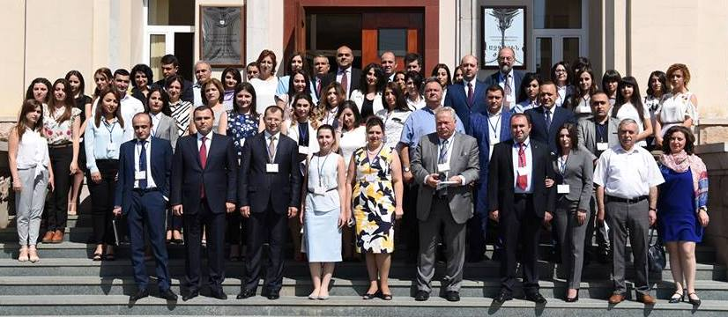 <https://www.youtube.com/watch?v=yecGAaX-EW8>

**On September 13-18, 2018,** the Third International Youth Conference **"The Past, Present and Future of Armenian Statehood"** was held in Stepanakert. 105 participants from 7 countries - USA, Belarus, Germany, Poland, Russian Federation, Armenia and Artsakh - applied for participation in the Conference. The works of 67 participants were published in the "Scientific Artsakh" journal, which is included in the list of peer-reviewed publications of the HAC of the Republic of Armenia.

Video material on the conference:<https://www.youtube.com/watch?v=JjEReP1SV44>

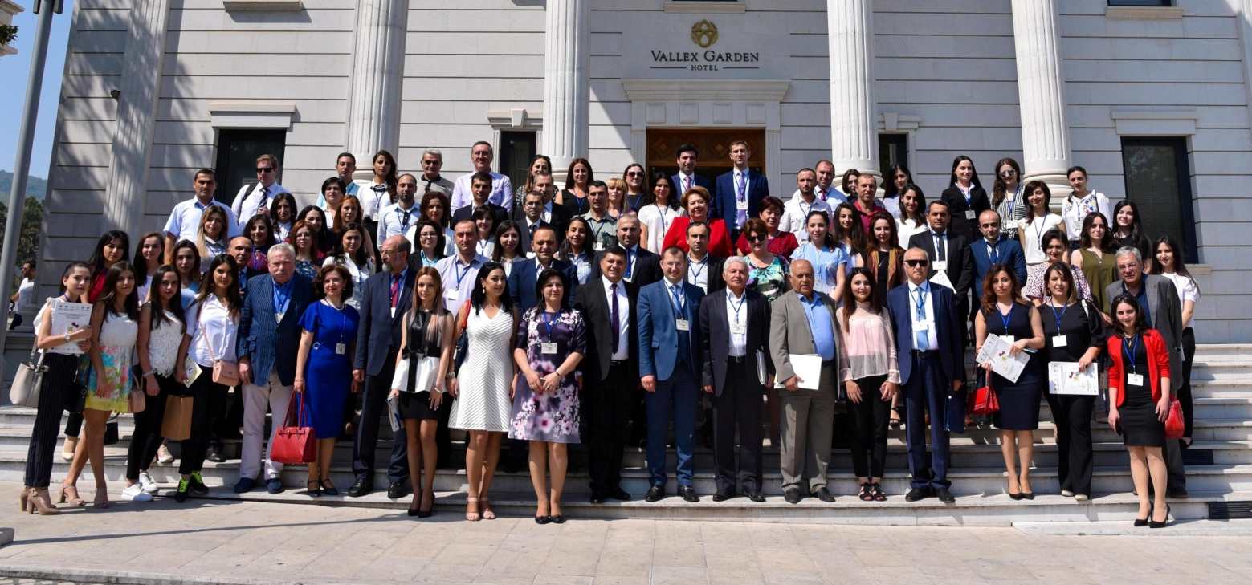

**The details on the Conference are also available in the "Announcements" section on the official website of the Organization** [**www.aegmm.org**](http://www.aegmm.org)**, and also in the "Scientific and Educational News" section on the website** [**www.artsakhlib.am**](http://www.artsakhlib.am)



**Application Form for**

**IV International Youth Scientific Conference**

**«THE PAST, PRESENT AND FUTURE OF THE ARMENIAN STATEHOOD»**

(Stepanakert, 12-15 September 2019)

|  |  |
| --- | --- |
| **Name/Surname** |  |
| **Date of birth** |  |
| **Academic degree** |  |
| **Educational Institution (Department, Chair)** |  |
| **The Heading of the Report**  **(English and Russian)** |  |
| **Academic adviser’s name/surname and academic degree** |  |
| **Form of participation (full-time / correspondence)** |  |
| **Country (city/town)** |  |
| **Address of residence (with zip code)** |  |
| **Phone number(s)** |  |
| **E-mail Address** |  |
| **Facebook ID** |  |

Please send the fully filled application form with the article to the following email address [armstatehoodconf@gmail.com](mailto:armstatehoodconf@gmail.com) **by July 31, 2019**.

For additional information please contact Avetik Harutyunyan, Ph.D in law, Associate Professor, the chairman of the organizing committee at [avetiq.hh@aegmm.org](mailto:avetiq.hh@aegmm.org).